**KPI’s Requirement:**

We need to analyze key indicator for our pizza sales data to gain insights into our business performance. Specially, we want to calculate the following metrics.

1. Total Revenue: The sum of the total price of all pizza orders.
2. Average Order Value: The average amount spent per order, calculated by dividing the total revenue by the total no. of orders.
3. Total Pizza’s Sold: The sum of the quantities of all pizzas sold.
4. Total Order’s: The total number of ordered placed.
5. Average Pizza per Order: The average number of pizzas sold per order, calculated by dividing the total number of pizzas sold by the total number of orders.

**Problem Statement:**

Chart Requirement:

We would like to visualize various aspects of our pizza sales data to gain insights and understand key trends.

1. Daily Trend for Total Orders
2. Monthly Trend for Total Orders
3. Percentage of Sales by Pizza Category
4. Percentage of Sales by Pizza size
5. Total Pizza’s Sold by Pizza Category
6. Top 5 Best Sellers by Revenue, Total Quantity and Total Order’s
7. Bottom 5 Best Sellers by Revenue, Total Quantity and Total Order’s

**PIZZA SALES SQL QUERIES**

1. KPI’S

-- Total Revenue

SELECT SUM(TOTAL_PRICE) AS TOTAL_REVENUE FROM pizza_sales  
  
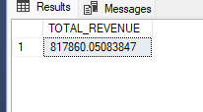

-- Average Order Value

SELECT SUM(TOTAL_PRICE)/COUNT(DISTINCT(ORDER_ID)) FROM pizza_sales

-- Total Pizza’s Sold

SELECT SUM(QUANTITY) AS TOTAL_PIZZA_SOLD FROM pizza_sales

-- Total Order’s

SELECT COUNT(DISTINCT(ORDER_ID)) AS TOTAL_ORDERS FROM pizza_sales

-- Average Pizza per Order

SELECT CAST(SUM(QUANTITY) AS DECIMAL(10,2))/CAST(COUNT(DISTINCT(ORDER_ID)) AS DECIMAL(10,2)) AS AVG_PIZZA_PER_ORDER FROM pizza_sales

-- Daily Trend for Total Orders

SELECT DATENAME(DW,ORDER_DATE) AS ORDER_DAY, COUNT(DISTINCT ORDER_ID) AS TOTAL_ORDER

FROM pizza_sales

GROUP BY DATENAME(DW,ORDER_DATE)

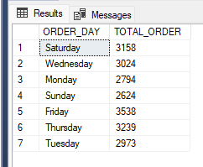

-- Monthly Trend for Total Orders

SELECT DATENAME(MONTH,ORDER_DATE)AS MONTH_NAME, COUNT(DISTINCT ORDER_ID) AS TOTAL_ORDER

FROM pizza_sales

GROUP BY DATENAME(MONTH,ORDER_DATE)

order by 1

-- Percentage of Sales by Pizza Category

SELECT PIZZA_CATEGORY,SUM(TOTAL_PRICE) AS TOTAL_SALES,SUM(TOTAL_PRICE) * 100 /(SELECT SUM(TOTAL_PRICE) FROM pizza_sales) AS PERCENTAGE_TOTAL_SALES

FROM pizza_sales

GROUP BY PIZZA_CATEGORY

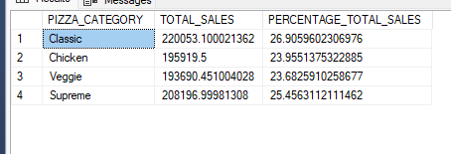

-- Percentage of Sales by Pizza size

SELECT PIZZA_SIZE,SUM(TOTAL_PRICE) AS TOTAL_SALES,CAST(SUM(TOTAL_PRICE) * 100 /

(SELECT SUM(TOTAL_PRICE) FROM pizza_sales) AS DECIMAL (10,2)) AS PERCENTAGE_TOTAL_SALES

FROM pizza_sales

GROUP BY PIZZA_SIZE

ORDER BY 3 DESC

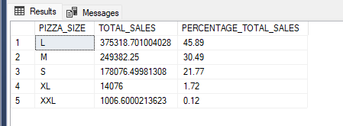

-- Total Pizza’s Sold by Pizza Category

SELECT PIZZA_CATEGORY,COUNT (QUANTITY) AS PIZZA_QUANTITY,CAST(SUM(TOTAL_PRICE)AS DECIMAL (10,2)) AS TOTAL_SALES

FROM pizza_sales

GROUP BY PIZZA_CATEGORY

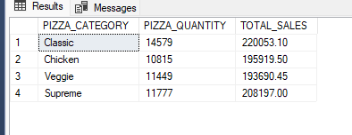

-- Top 5 Best Sellers by Revenue, Total Quantity and Total Order’s

SELECT TOP 5 PIZZA_NAME,SUM(TOTAL_PRICE) AS TOTAL_REVENUE FROM pizza_sales

GROUP BY PIZZA_NAME

ORDER BY 2 DESC

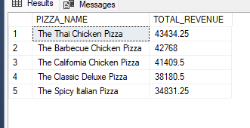

-- Bottom 5 Best Sellers by Revenue, Total Quantity and Total Order’s

SELECT TOP 5 PIZZA_NAME, SUM(TOTAL_PRICE) AS TOTAL_REVENUE FROM pizza_sales

GROUP BY PIZZA_NAME

ORDER BY 2

